**EXPERINMENT 3**

**Aim :** To study Contrast stretching, Intensity level slicing and Bit plane slicing.

* **Exercises :**

1. **Do contrast stretching For the Image given in Figure 3.10 of the Textbook. Obtain Contrast stretched Image from Low contrast Image as given in Figure 3.10 (c).**

* **Solution :-**

Code :

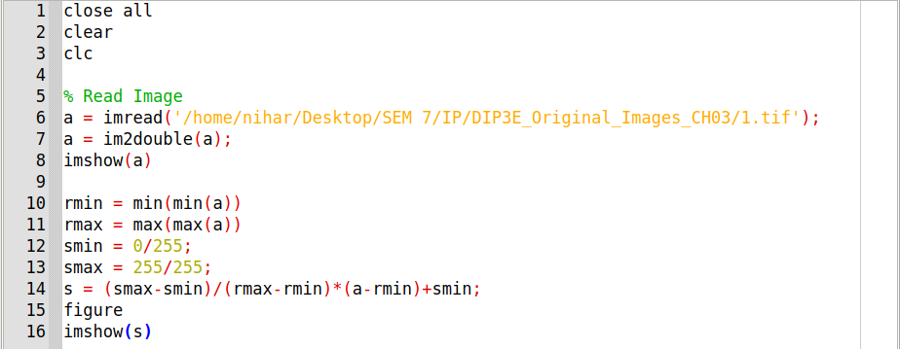

Input Image :

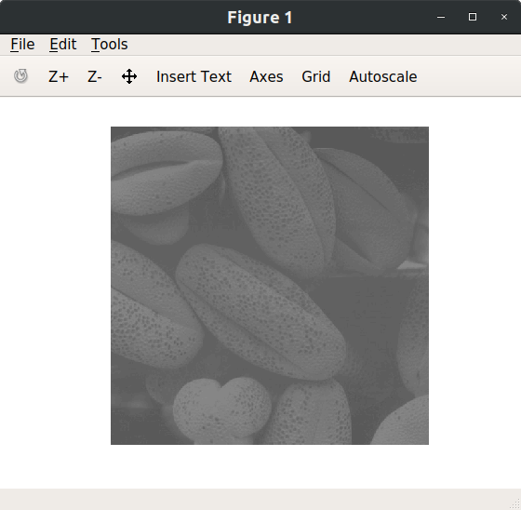

Output Image :

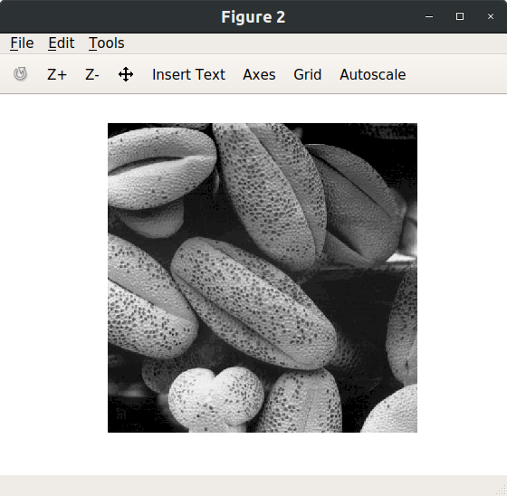

1. **Take any family photo of yours – convert it into grayscale- reduce it’s contrast by using the function that was defined during lab session. Enhance the contrast of that image using piecewise linear operation for contrast stretching.**

* **Solution :-**

Code :

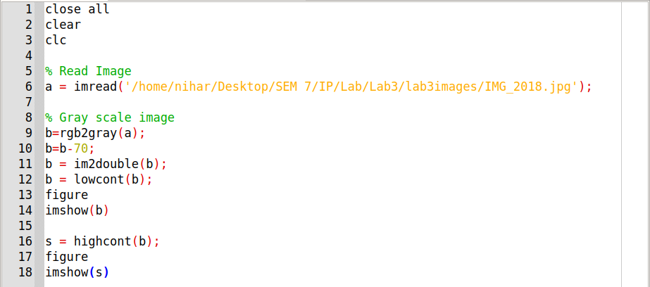

Low Contrast Function :

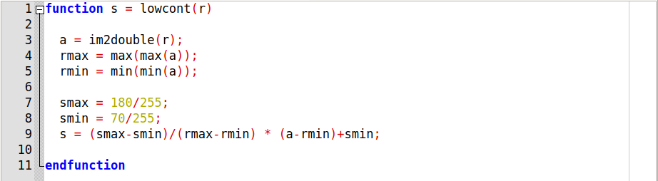

High Contrast Function :

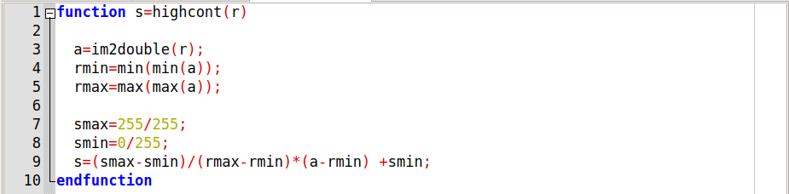

Input Image :

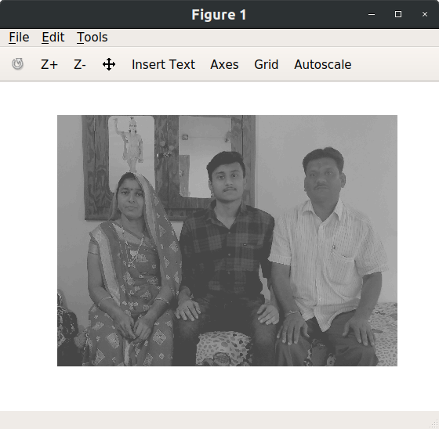

Output Image :

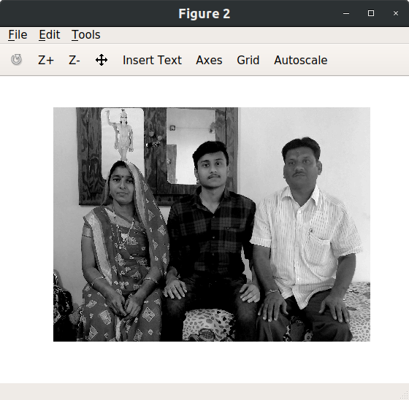

1. **Apply thresholding to any of your gray scale photo.**

* **Solution :-**

Code :

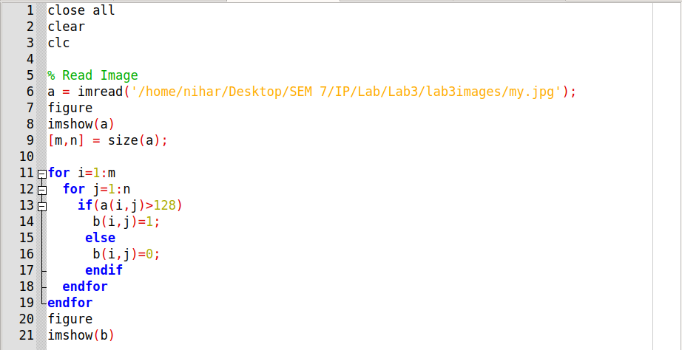

Input Image :

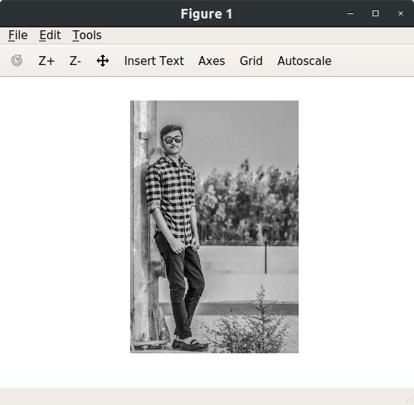

Output Image :

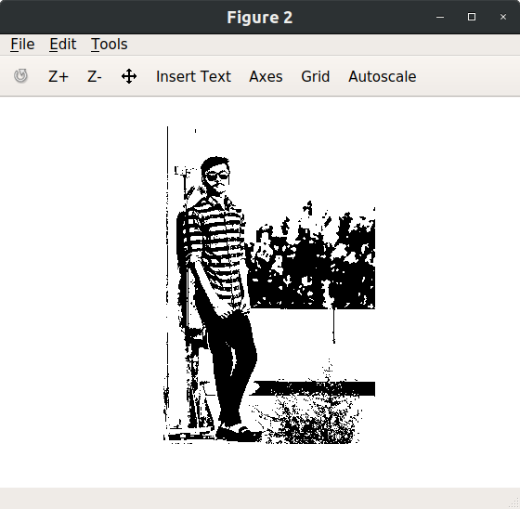

1. **Take your photo and separate out its bit plains. Reconstruct the given image using higher order 2 bit planes. Reconstruct the given image using higher order 4 bit planes. Experiment with the bit planes and derive your conclusions.**

* **Solution :-**

Code :

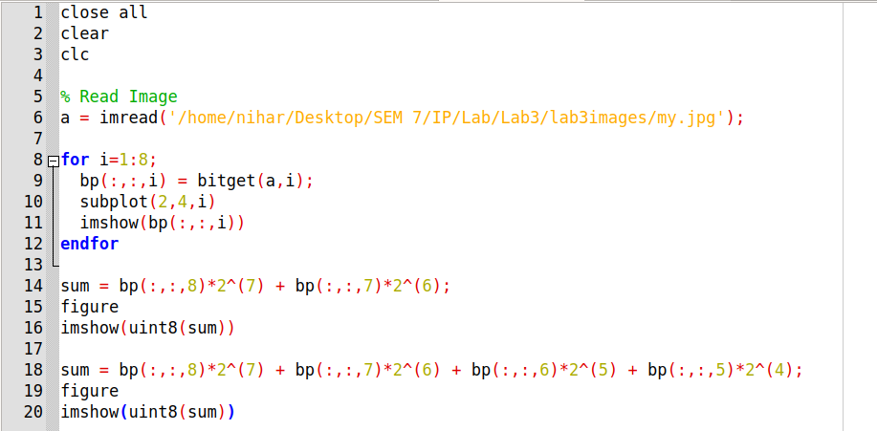

Output Images :

8 bit planes

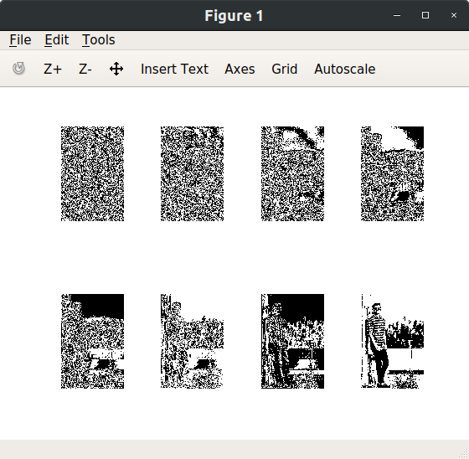

Reconstructed image using higher order 2 bit planes

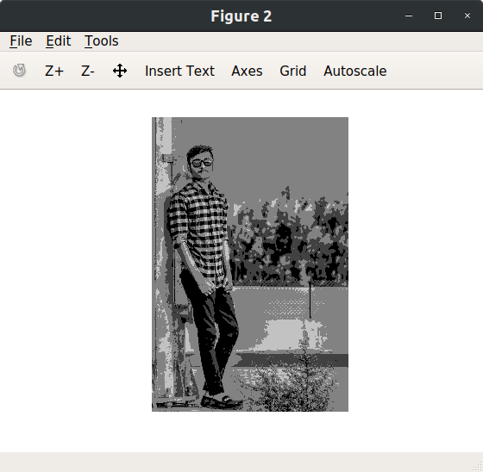

Reconstructed image using higher order 4 bit planes

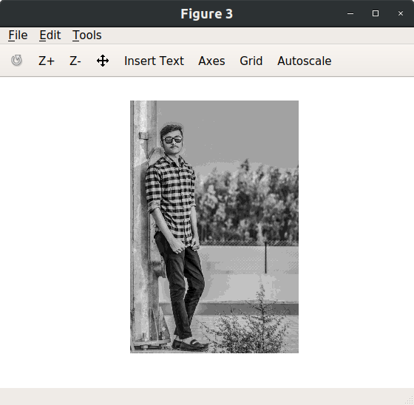

1. **Perform intensity slicing to separate out red green baloons form the image given.**

* **Solution :-**

Code :

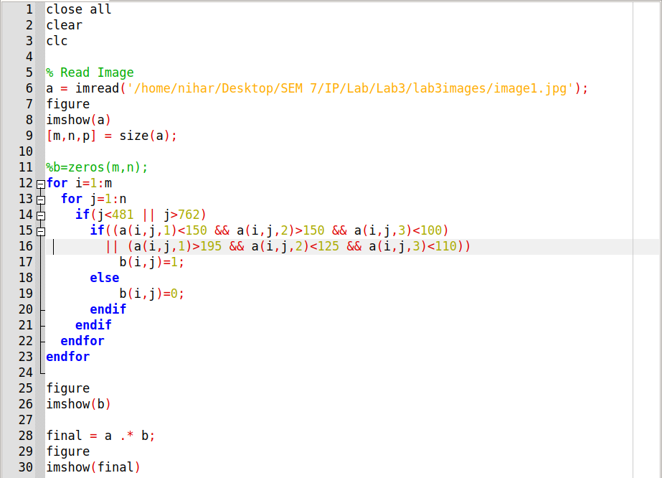

Input Image :

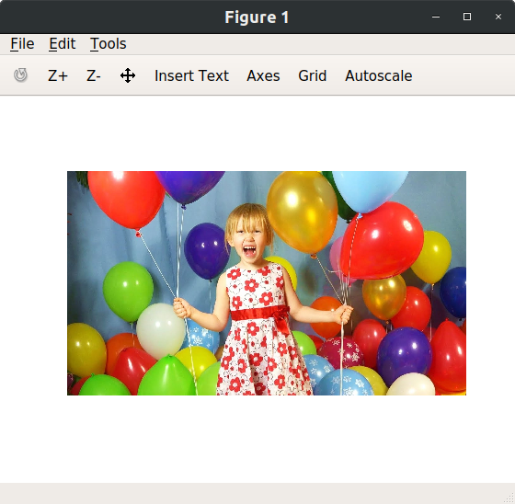

Output Images :

